**DAILY ONLINE ACTIVITIES SUMMARY**

|  |  |  |  |  |  |  |  |  |
| --- | --- | --- | --- | --- | --- | --- | --- | --- |
| **Date:** | **19 June 2020** | | | | | **Name:** | **K ISHA HEGDE** | |
| **Sem & Sec** | **4th sem, 2nd year** | | | | | **USN:** | **4al18cs031** | |
| **Online Test Summary** | | | | | | | | |
| **Subject** | | **MICROCONTROLLER AND EMBEDDED SYSTEMS (18cs44)** | | | | | | |
| **Max. Marks** | | **20** | | **Score** | | | **18** | |
| **Certification Course Summary** | | | | | | | | |
| **Course** | **INTRODUCTION TO DIGITAL MARKETING** | | | | | | | |
| **Certificate Provider** | | | **DIGITAL GARAGE** | | **Duration** | | | **5 hours** |
| **Coding Challenges** | | | | | | | | |
| **Problem Statement:2 program** | | | | | | | | |
| **Status: Executed** | | | | | | | | |
| **Uploaded the report in Github** | | | | | **Yes** | | | |
| **If yes Repository name** | | | | | **<https://github.com/iishaii/locked-down_coding>** | | | |
| **Uploaded the report in slack** | | | | | **Ye** | | | |

#### Online Test Summary

#### Today MICROCONTROLLER AND EMBEDDED SYSTEMS (18cs44) exam was conducted for 20 marks for duration of 30 min.

#### 

#### Certification Course Summary:

#### Today I started with DIGITAL MARKETING in GOOGLE DIGITAL GARAGE which is of 40 hrs. After the completion of course, certificate will be provided. Today I completed 5 modules .

#### 

**Coding Challenges:**

Today I solved 2 coding challenge,

1. **Write a C Program to Count total set bits in all numbers from 1 to n**

Given a positive integer n, count the total number of set bits in binary representation of all numbers from 1 to n.

**Examples:**  
Input: n = 3  
Output: 4  
Input: n = 6  
Output: 9

**Hint:** Read a positive integer (example: 3 indicates range), so u have to consider 1, 2, 3 as the input convert these numbers into binary and count the number of 1 in that (1- 0001, 2- 0010, 3- 0011) number of 1s from all 3 digit is 4 so the answer is 4

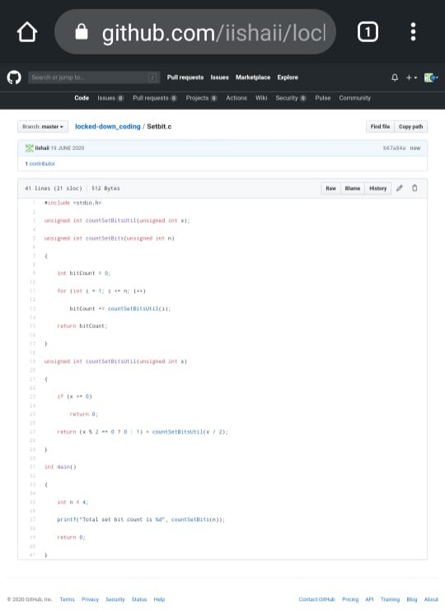

2.  **Write a C Program to rotate a Matrix by 90 Degree in Clockwise or Anticlockwise Direction**.

Matrix Rotation by 90 Degree in Clockwise Direction:

Input:  
Enter the total Number of Rows m: 3  
Enter the total Number of Columns: 3  
Enter the Elements of the Matrix:  
1 2 3 4 5 6 7 8 9  
Output:  
The Given Matrix is:  
1 2 3  
4 5 6  
7 8 9  
The Output Matrix After Rotation by 90 Degree in Clockwise Direction is:  
7 4 1  
8 5 2  
9 6 3

Matrix Rotation by 90 Degree in Anticlockwise Direction:

Input:  
Enter the total Number of Rows m: 3  
Enter the total Number of Columns: 3  
Enter the Elements of the Matrix:  
1 2 3 4 5 6 7 8 9  
Output:  
The Given Matrix is:  
1 2 3  
4 5 6  
7 8 9

The Output Matrix After Rotation by 90 Degree in Clockwise Direction is:  
3 6 9  
2 5 8  
1 4 7

